***LAB 11***

***TASK 01 Farenheit to kelvin***

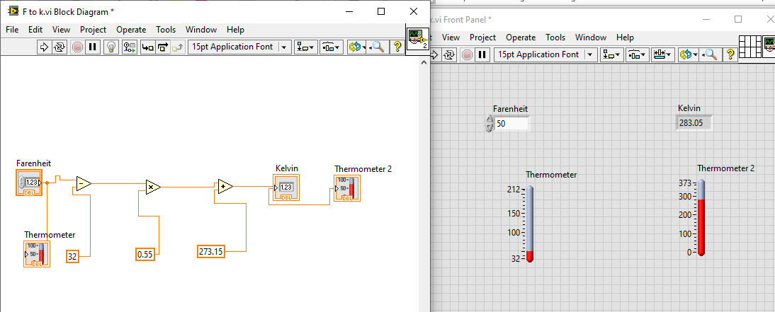

***TASK 02 kelvin to degree***

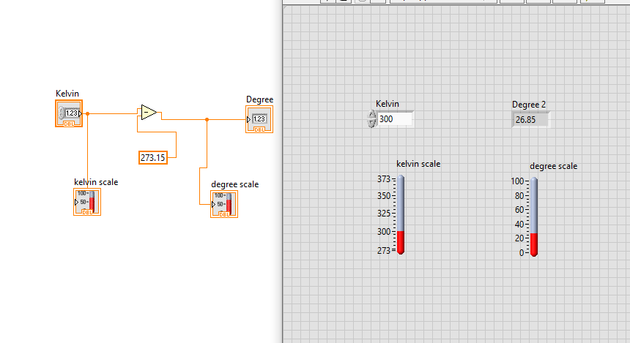

***Task03 kelvin to farenheit***

